**ELECTRIC VEHICLE DATA ANALYSIS — BUSINESS CASE REPORT**

### **1. Problem Definition**

The objective was to analyze the landscape of Electric Vehicles (EVs) to understand market size, growth patterns, technology progression, and regional adoption trends. The analysis targeted both Battery Electric Vehicles (BEVs) and Plug-in Hybrid Electric Vehicles (PHEVs) while assessing Clean Alternative Fuel Vehicle (CAFV) eligibility and manufacturer dominance.

### **2. Analysis Approach**

**Data Inputs:** Electric Vehicle registration dataset including fields for vehicle make, model, model year, electric range, state, and CAFV eligibility.  
 **KPIs Evaluated:**

* Total Vehicles
* Average Electric Range
* Total BEV Vehicles and % of Total
* Total PHEV Vehicles and % of Total

**Visual Analytics Implemented:**

1. **Total Vehicles by Model Year (2011–2024)** – Area chart tracking EV growth trends over time.
2. **Total Vehicles by State** – Geographic heat map to visualize EV distribution across U.S. states.
3. **Top 10 Vehicles by Make** – Horizontal bar chart ranking top EV manufacturers by volume.
4. **Total Vehicles by CAFV Eligibility** – Donut chart showing eligibility proportions.
5. **Top 10 Vehicles by Model** – Tree map displaying dominant models by total vehicles.

### **3. Key Insights**

**Overall Market Size:**

* Total registered EVs: **150,422**

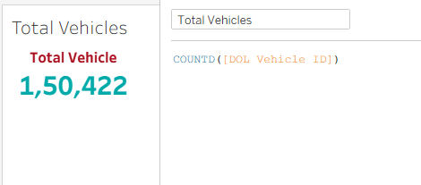

* Average Electric Range: **67.83 miles**

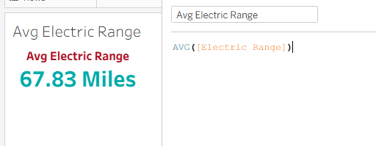

**Market Composition:**

* **BEVs:** 116,750 units (**77.6%**)

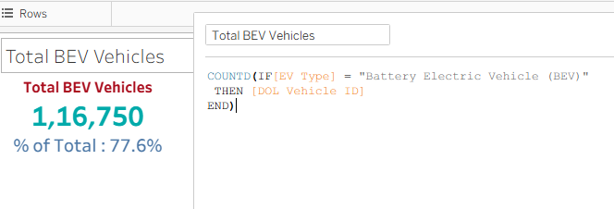

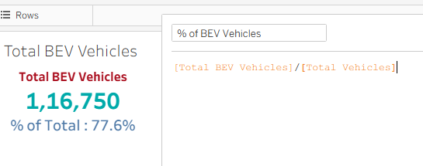

* **PHEVs:** 33,672 units (**22.4%**)  
   The dominance of BEVs highlights accelerating consumer transition to fully electric platforms.

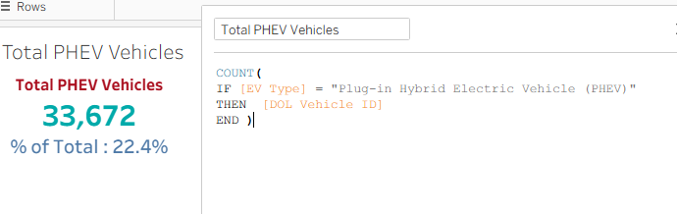

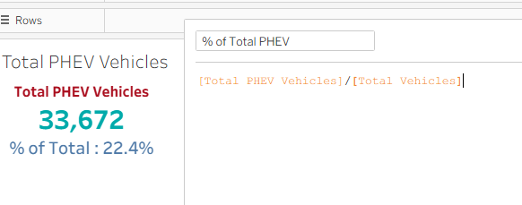

**Adoption Trend:**

* Continuous growth from 2011 onward, with a major surge post-2018.
* Peak adoption year: **2023** with over **37K** vehicles.
* Growth trajectory confirms increasing market confidence and expanding EV infrastructure.

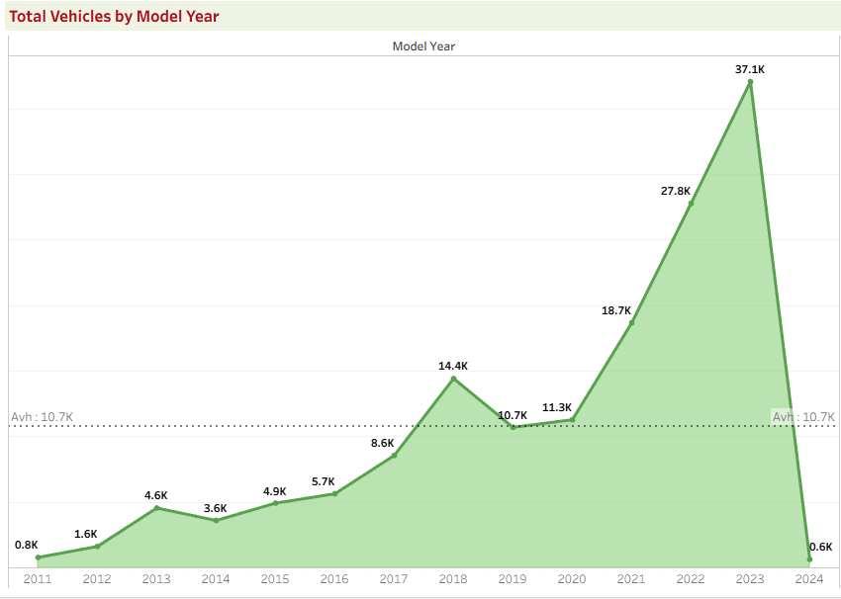

**Regional Concentration:**

* **California** leads national adoption with over **50K** vehicles, followed by Washington, Oregon, and New York.
* Coastal states exhibit higher penetration linked to incentives and infrastructure readiness.

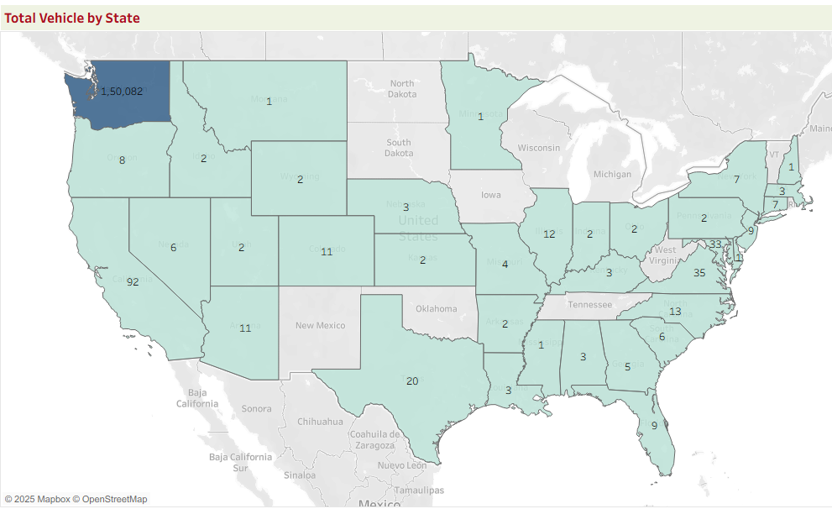

**Manufacturer Dominance:**

* **Tesla** accounts for ~69% of all EVs, cementing its leadership in the market.
* Secondary contributors: Nissan, Rivian, Chevrolet, and Ford.

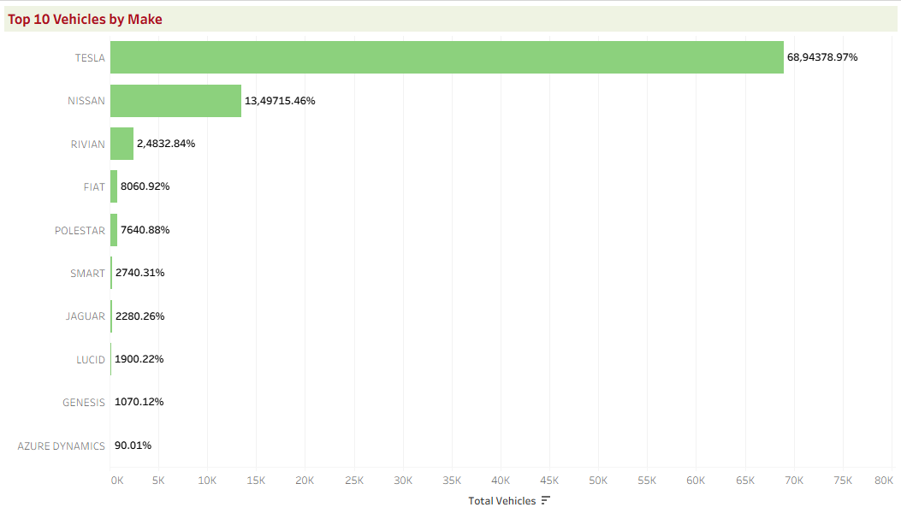

**CAFV Eligibility:**

* **Eligible:** 41.8%
* **Not Eligible:** 11.8%
* **Unknown:** 46.3%  
   CAFV incentives appear to correlate with adoption spikes in eligible regions.

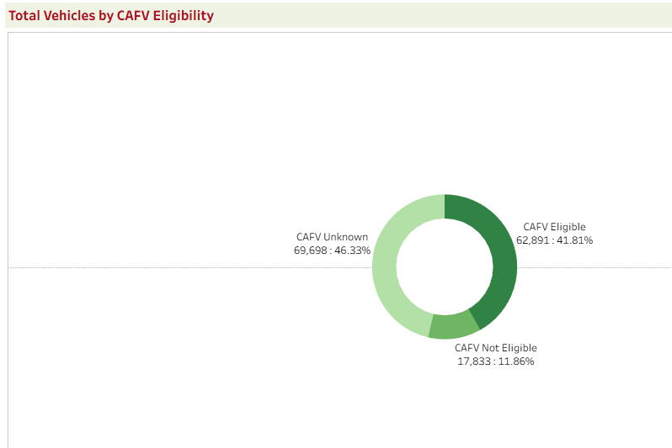

**Model Popularity:**

* **Top Models:** Tesla Model Y, Model 3, and Nissan Leaf lead the segment.
* Model Y alone comprises nearly **19%** of total EVs, underscoring Tesla’s product-market alignment.

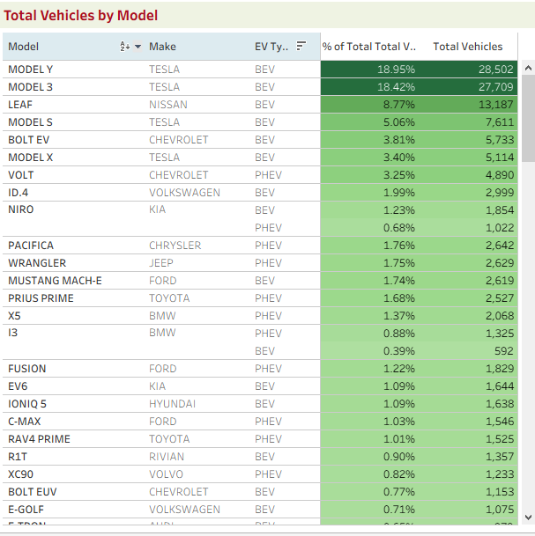

**4. Dashboard**

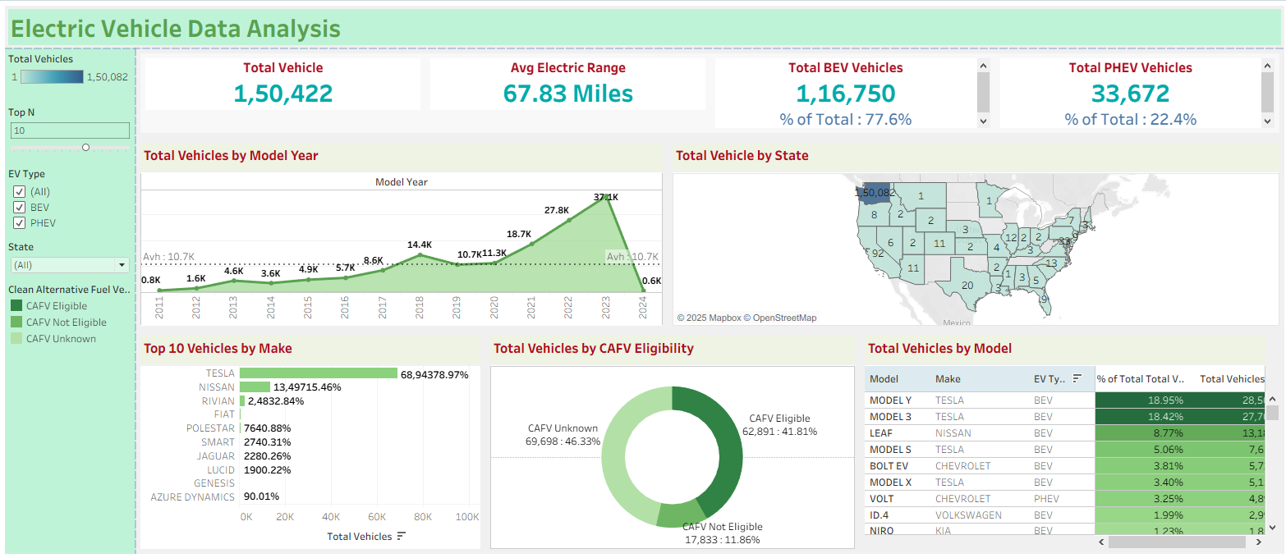

### **5. Business Impact**

* **Market Growth Validation:** The dataset validates sustained growth and consumer confidence in EV adoption.
* **Policy Insight:** States with CAFV programs show higher penetration, proving incentive effectiveness.
* **Investment Guidance:** High BEV ratio signals infrastructure demand for charging networks.
* **OEM Strategy:** Competitive pressure evident; emerging brands must differentiate through range, affordability, or feature innovation.

### **6. Outcome Summary**

This analysis provides a holistic snapshot of the EV ecosystem—quantifying adoption, range efficiency, regional concentration, and manufacturer dynamics. It establishes a data-backed foundation for investment, policy, and strategic business decisions in the electric vehicle domain.